A MICROPROJECT REPORT

ON

“WATER LEVEL CONTROLLER”
Department of Electronics & Telecommunication Engineering

Submitted by
LAVANYA BAWANE-23003014
MANASVI WAGH-23003019
ANKITA CHANDARNE-23003013

Under the guidance of
Prof. Madhura Kulkarni

Academic Year 2024 – 2025


DEPARTMENT OF ELECTRONICS & TELECOMMUNICATION ENGINEERING
ST. VINCENT PALLOTTI
COLLEGE OF ENGINEERING AND TECHNOLOGY
Wardha Road, Gavsi Manapur, Nagpur-441108

CONTENT

TITLE PAGE NO.

- CHAPTER1: INTRODUCTION 5

- CHAPTER2: OBJECTIVE 7

- CHAPTER3: METHODOLOGY 9

- Components 9
- Circuit diagram 9
- Description of each component 10
- Working 11
- Project Photo 12

- CHAPTER4: APPLICATIONS 14

CHAPTER1
INTRODUCTION

INTRODUCTION:

This project focuses on developing an IoT-based Water Level Controller using the ESP32 microcontroller, a powerful and cost-effective platform that supports both Wi-Fi and Bluetooth connectivity. The system employs an ultrasonic sensor to measure the water level in a tank and sends the data to the ESP32, which processes the readings and controls the water pump accordingly. The entire system can be monitored and managed remotely through a mobile application or a cloud-based dashboard, providing users with convenience and control from any location.
The proposed system aims to automate the process of tank refilling, prevent water overflow, and protect the water pump from running dry. It also serves as a step toward smarter water management solutions, contributing to the broader goals of sustainability and resource conservation. By leveraging IoT capabilities, this project offers a reliable, low-maintenance, and scalable solution that can be customized for various applications, from small household setups to larger industrial systems.

CHAPTER2:
OBJECTIVE

OBJECTIVE:

The primary objectives of this IoT-based water level controller project are:
- To design an automated system that monitors and controls water levels in a tank using the ESP32 microcontroller.
- To reduce water wastage caused by manual monitoring and overflow.
- To enable remote monitoring of tank water levels via a mobile app or cloud dashboard.
- To automatically operate a water pump based on pre-defined level thresholds.
- To provide real-time alerts and data logging for better resource management.

CHAPTER3:
METHODOLOGY

REQUIRED COMPONENTS FOR IOT BASED WATER CONTROLLER

- ESP32 DEV KIT V1
- ultrasonic sensor
- 0.96″ I2C OLED Display
- 220-ohm 0.25watt Resistors – 2 no
- BC547 NPN Transistor
- LED 5mm – 1no
- 2-pin Push Button
- 2-pin Terminal connectors (3 no)
- 5V DC Buzzer

CIRCUIT DIAGRAM:

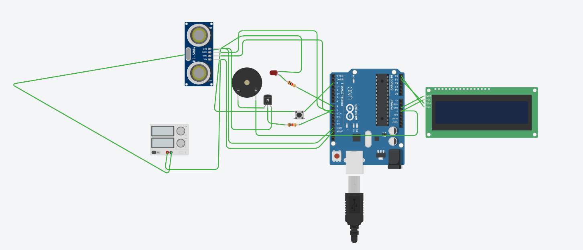

DESCRIPTION OF EACH COMPONENT:

1. ESP32 DEVKIT V1:
A microcontroller board with Wi-Fi and Bluetooth capabilities, ideal for IoT projects. It has a powerful dual-core processor, ample memory, and various peripherals.

2. Ultrasonic Sensor:
Measures distance using high-frequency sound waves. It calculates the time-of-flight of the sound waves to determine the distance from the sensor to an object (in this case, the water level).

3. 0.96" I2C OLED Display:
A small, high-resolution display that shows text, graphics, and other information. It's connected via I2C protocol, making it easy to integrate with microcontrollers like the ESP32.

4. BC547 NPN Transistor:
A bipolar junction transistor used for switching or amplification. In this project, it might be used to control the buzzer or LED.

5. LED (5mm):
A light-emitting diode that provides visual indication of the water level status or other events.

6. 2-pin Push Button:
A simple switch that allows users to interact with the system, potentially used to reset, calibrate, or trigger specific actions.

7. 220-ohm Resistors:
Limit the current flowing through components like LEDs, preventing damage and ensuring safe operation.

8. 5V DC Buzzer:
An audible alarm that sounds when the water level reaches critical points or other events occur, providing an alert to users.

These components work together to create a functional water level controller with real-time updates, alerts, and visual indicators.

WORKING OF WATER LEVEL CONTROLLER:

The system works by continuously control and monitor the water level using the ultrasonic sensor, which sends the data to the ESP32 microcontroller for processing. The ESP32 then displays the current water level on the OLED screen, providing a clear and concise visual representation of the water level status. If the water level reaches critical points, the system triggers alerts through the buzzer and LED, ensuring timely notifications. Additionally, the ESP32 can send the water level data to a cloud or server via Wi-Fi, allowing for remote monitoring and analysis. This seamless integration of hardware and software enables efficient water management and timely interventions.

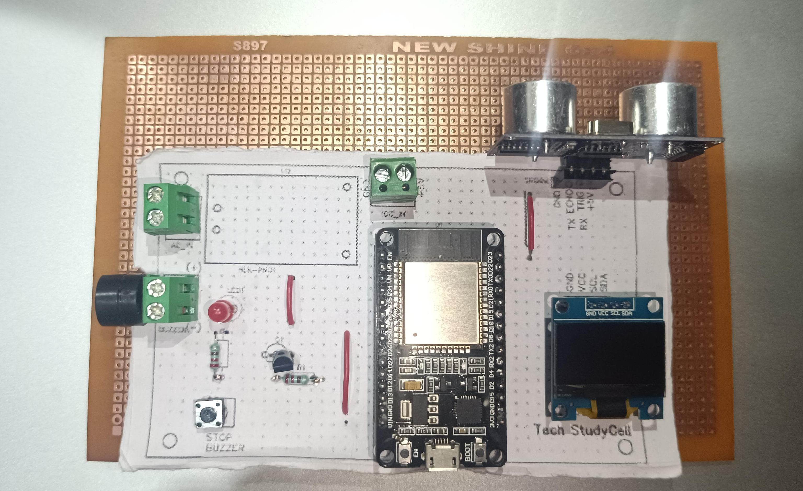

PROJECT PHOTO

CHAPTER4:
APPLICATIONS

APPLICATIONS:

The water level monitoring system has various applications:

1. Residential Water Tanks: Monitor water levels, preventing overflow and ensuring efficient water usage.
2. Industrial Processes: Control liquid levels in tanks, ensuring process efficiency and safety.
3. Irrigation Systems: Optimize water usage, reducing waste and improving crop yields.
4. Flood Detection: Monitor water levels, providing early warnings for flood prevention.
5. Water Conservation: Encourage efficient water usage, reducing waste and promoting sustainability.

These applications showcase the system's versatility and potential to improve water management across various sectors.

